Temperature, Rainfall, and Biome Distribution Lab
Welcome to your climatogram lab. In this lab you will investigate the relationship between the amount of rainfall and the variance of temperature and the effect on the distribution of biomes globally.
Purpose:
This exercise provides practice in associating climate (as expressed in monthly averages of precipitation and temperature) with biomes. You will also make predictions about the distribution of a biome via altitude and latitude.
Large ecosystems or biomes can be described in terms of their climate, or long-term weather patterns. The climate of a biome is the result of the interaction of several abiotic factors. These factors include temperature, precipitation, and radiant energy from the sun, evaporation, wind and humidity. These abiotic factors serve to limit the diversity of plants and animals found within an ecosystem. The two most important of these limiting abiotic factors are temperature and precipitation. A climatogram is a graph with a double-Y axis that plots the average monthly temperature & precipitation in a biome.
Climatograms of a large ecosystem (or biome) show variation in only two factors- temperature and precipitation. Although there are other factors that affect the climate, a climatogram does give a rough idea of the climate in a particular biome.

Procedure:

Part I: Building a library of examples
Graph the climate figures for precipitation and temperature for the four locales in Group 1 onto your blank climatogram sheets (found at the end of the packet). Be sure that you label each location and it's biome name. Also be extremely careful as to how you record the information. All temperature readings are measured on the right side of the climatogram! All precipitation measurements are on the left side of the climatogram! Be sure to draw a line graph for temperature data and a bar graph for precipitation data. Calculate the average temperature and average precipitation for each data set. Record these values on your climatogram.

Group 1

Cuiaba, Brazil: Tropical Deciduous Forest
J F M A M J J A S O N D

Precipitation (in cm): 24.9 21.1 21.1 10.2 5.3 0.8 0.5 2.8 5.1 11.4 15 20.6
Temperature (in C°): 27.2 27.2 27.2 26.6 25.6 23.9 24.4 25.6 27.8 27.8 27.8 27.2
Average Rainfall in cm: __11.57________________
Average Temperature in Celsius: ____24.20______
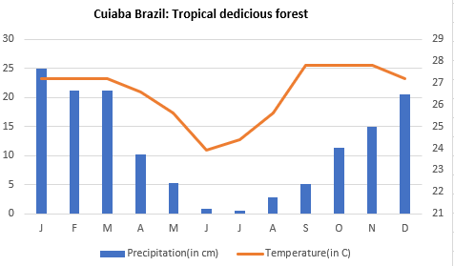

Santa Monica, California: Chaparral
J F M A M J J A S O N D

Precipitation (in cm): 8.9 7.6 7.4 1.3 1.3 0 0 0 0.3 1.5 3.5 5.8
Temperature (in C°): 11.7 11.7 12.8 14.4 15.6 17.2 18.9 18.3 18.3 16.7 14.4 12.8
Average Rainfall in cm: __3.12________________
Average Temperature in Celsius: _15.23_________
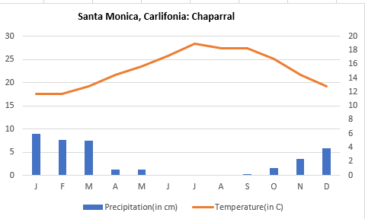

Moshi,Tanganyika: Tropical Grassland
J F M A M J J A S O N D

Precipitation (in cm): 3.6 6.1 9.2 40.1 30.2 5.1 5.1 2.5 2 3 8.1 6.4
Temperature (in C°): 23.3 23.2 22.2 21.1 19.8 18.4 17.9 18.4 19.8 21.4 22 22.4
Average Rainfall in cm: ____10.12______________
Average Temperature in Celsius: _19.29_________
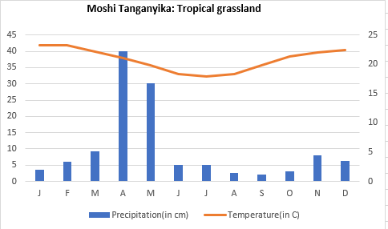

Aden, Aden: Tropical Desert
J F M A M J J A S O N D

Precipitation (in cm): 0.8 0.5 1.3 0.45 0.3 0.3 0 0.3 0.3 0.3 0.3 0.3
Temperature (in C°): 24.6 25.1 26.4 28.5 30.6 31.9 31.1 30.3 31.1 28.8 26.5 25.1
Average Rainfall in cm: ___0.43_______________
Average Temperature in Celsius: __28.63________
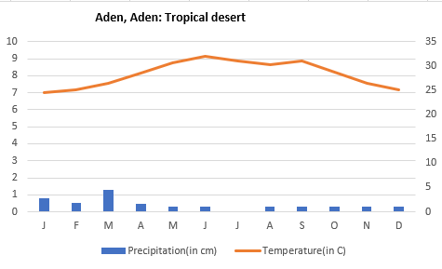

Combined with the six climatograms given below as examples (see below), you now have ten climatograms representing ten different biomes found worldwide.
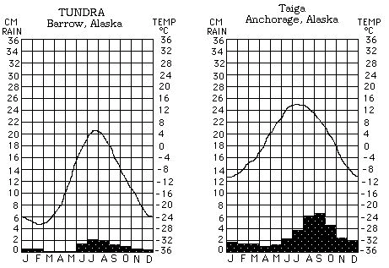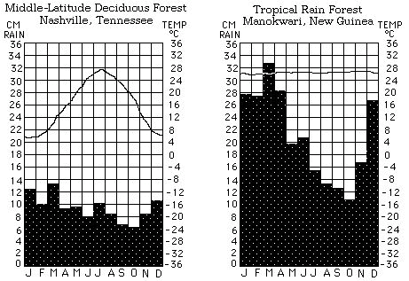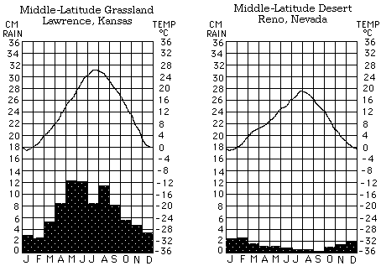
Part II: San Francisco
Now graph the information for San Francisco.
J F M A M J J A S O N D
Precipitation
4.5 2.8 2.6 1.5 0.3 0.1 0 0.1 0.2 1.1 2.5 3.5
(in cm):
Temperature

13.0 15.0 16.0 17.0 17.0 19.0 18.0 18.0 21.0 20.0 17.0 14.0 (in C°):
Average Rainfall in cm: ___1.6_______________
Average Temperature in Celsius: __18.03________

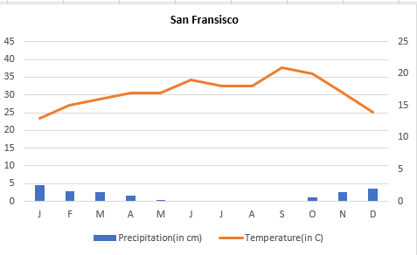

Compare the climatogram for San Francisco with the ten known Biomes from Part I.
Answer the following questions about San Francisco
- What biome is San Francisco found in? Consult your textbook.
San Francisco is found the Chaparral biome.
- Which of the known biome climatograms closely resembles San Francisco?
Santa Monica.
  - In what ways were they similar?
They both experience precipitation below 10 cm and there was no precipitation in the month of July
  - In what ways were they different?
Santa Monica and San Francisco are different in such a way that San Francisco received a little less rain than Santa Monica and its temperatures were a little higher than Santa Maria.
  - Would you consider them to truly be the same biome? Explain?
Yes. San Francisco and Santa Maria may be the same biome. This is because both regions possess climates that are similar to that of the Mediterranean area which are usually characterized by hot, dry summers and cold, wet winters.
  - During the thirty-year period used for the figures in the San Francisco climatogram there were four drought periods. How would this effect the appearance of the climatogram?
Existence of drought leads to increase in temperatures of San Francisco and the amount of precipitation will significantly drop. Therefore, the temperature curve will form a dome while the precipitation graph will also drop in values.

